Question from Rod:
Could the date possibly be July?
Any evidence of when received at Kew? In e-mail of 30 April to Rod I said we will 'get an image of the marking 'V5976' so that you can compare with the standard markings of that period. I wonder whether it was sent to Kew by the Govt, and not M, so I'll look for letters from Wilson or others in the same guardbook, perhaps thanking Hooker for his material.
When checked, no covering letter was found in the same Guard book

Clearly and unambiguously June:
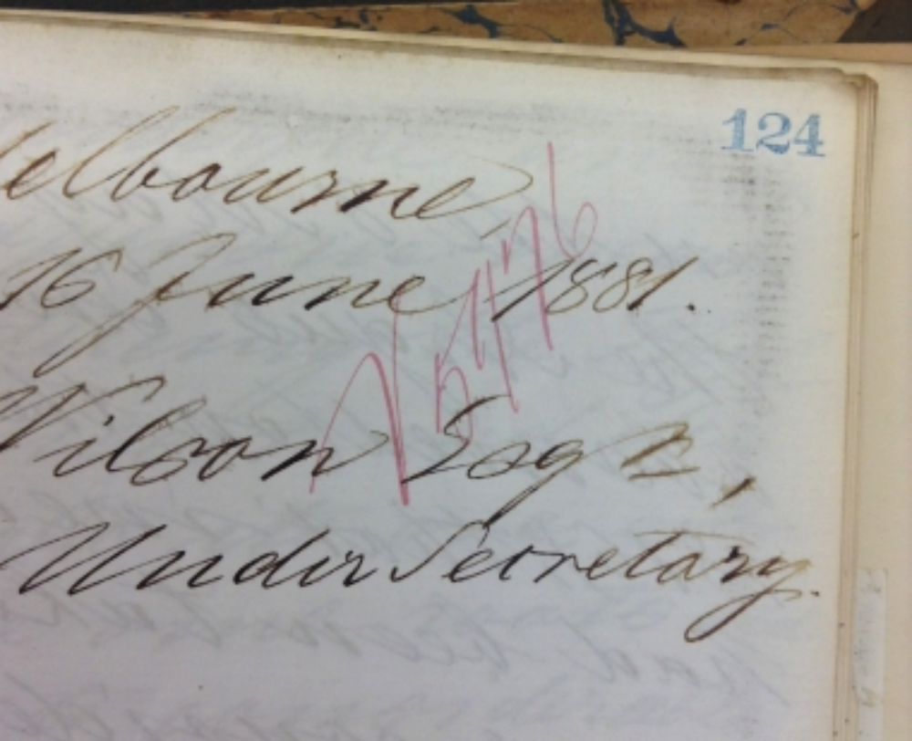

Rod's email of 27 June 2014:
Given that the date on the letter we have as 81-06-16 is so clearly 16 June, there seem to be two possible explanations: (1) the letter was mis-dated by M and was actually written on 16 July, in reply to Wilson's request of 13 July; or (2) M's date is correct, and the letter is a reply to an earlier request that we haven't found.

I incline to the latter because (a) a mis-dating such as proposed would be an unlikely mistake for M to make; (b) the things that M says he's including with the letter are not, in fact, the things Wilson asked for in his letter of 13 July; and (c) as you note, if it was only written on 16 July, it's hard to understand how the various colonies could have agreed only a few days later to send it to London, since the people in Sydney and Adelaide would have been hard-pressed even to see it by 22 July.

I'll look in the registers at the PRO for the days following 16 June, as you suggest, to see if a letter from M is recorded as being received then, and at the registers of outgoing mail for the days immediately before 16 June for evidence of a letter being sent to him, to which the item we have might be a reply.

Rod e-mail 9 March 2018:
81-06-16
I'm aware of the need to settle on a date for this item. I haven't been to the PRO recently, but am assembling a small pile of items that need to be followed up there.
Noted, I expected something like that, but mentioned it because it has been sitting around for a long time.

81.06.16
To Thomas Wilson
RBG Kew, Miscellaneous reports 7.7, Victoria, Phylloxera, 1876-90 (MR/415), ff. 124-31.

Melbourne
16 June 1881.
T. R. Wilson Esqr.,
Acting Under Secretary

Sir.
In compliance with the request of the honorable the Chief Secretary, I have the honor of remitting herewith the copy received by me of the despatches from the Colonial Office to his Excellency Governor Sir George Bowen, dated 15 febr. 1876; and I remit therewith also the copy of a letter from the Director of the Royal botanic Garden of Kew, Sir Jos. Hooker together with the translation of Baron Dumas's and Dr Max Cornu's Report on the means of counteracting the ravages of the Phylloxera vastatrix, which translation with Dr Hookers letter appeared already on the 8 May 1876 in the Argus. In reply I observed (on the 12 May 1876), that measures had been taken already some considerable time before by the Victorian Government to prohibit the importation of any living vines, with a view of guarding thus against the ingress of this parasite into the colony. As regards the Sulpho-Carbonates of Potassium and of other alkalies they are doubtless as insect-destroying agents of some importance for suppressing also the Phylloxera vastatrix; but their use has since to a great extent been superseded by the application of the Bisulphide of Carbon, which fluid, — through its suffocating properties, great volatility and extreme expansiveness — has hitherto afforded the most powerful and least expensive means for subduing the Phylloxera-insect and destroying also its ova, even where the vine-roots did penetrate to considerable depth, and in elevated and sloping localities, where the inundation-process cannot be employed. Of this newer treatment with Bisulphide of Carbon, as recorded by Mons. Marion, (Dr David refers also to it) a translation has been furnished last year with addition of many other notes bearing on the Phylloxera-question by our fellow-colonist, Mr A [K] Finlay, after that Gentleman's visit to the Vine-districts of France. In the new edition of my work on "select extra tropic plants for industrial culture and naturalisation", issued soon subsequently (also in 1880) with permission of the honourable the Chief Secretary of Victoria by the New South Wales's Government, I have at page 355 also briefly alluded to some of the various measures, recommendable against the Vine-Phylloxera. May the hope here be expressed, that it will be possible to bring out also soon in our own Gov. Printing Office a still further enlarged edition of this work, in which then the remedies against the Phylloxera could also more fully be treated. It seems opportune to point out on this occasion, that the invasion of the Phylloxera into Victoria took place fully 8 years ago, if not earlier. A Swiss Vine-grower, settled near Geelong, when on a visit to his native country, brought back with him some varieties of Vine, which were affected — unknown to him — by the Phylloxera vastatrix, at that time a general alarm of the severity of the disease, caused by this minute but destructive creature, not having then been raised; moreover as the insidious cause of the lingering and final perishing of his vines was not detected till some years afterwards, the winged insect had widely spread through the Geelong-district, if not already further, when towards the end of 1877 the presence of the formidable Phylloxera in the Geelong-Vineyards was actually recognised. This happened while I was engaged by permission of the honourable the Ministerial Chief in a three months collecting journey in West-Australia for the furtherance of the Australian Universal Flora; and already prior to my return the Commissioners, appointed with promptitude's by the hon. the Minister of Agriculture, had set to work at their arduous task to stamp out the disease. It is but just, to point also out at once, that I had myself not the slightest suspicion of the immigration of the Phylloxera into Victoria or any part of Australia, when its existence was suddenly discovered; this is all the more readily explained by the fact of my ceasing to be connected with any cultural operations whatever, when in 1873 the whole Botanic garden with all its plants, as well as its office-building and all other appliances, established there by myself, were withdrawn from me, whereby I was thrown out of all cultural intercourse's and communications and whereby my attention, in accordance with the desire of the then Ministry became restricted to the elucidation of the Australian Flora mainly, if not solely. It is also but fair to observe, that the weekly papers of Victoria and often also the daily journals of our colony since fully 10 years and even earlier gave notices to the general public on the gradual progress of the Phylloxera through South-Europe, by which means every intelligent cultivator, whether of vineyards or of a few vines at his domicile, ought to have been placed on his guard, so as to check the dreaded invader at once, should the slightest signs of its appearance manifest themselves anywhere in our colony. The Department of Agriculture and likewise the Acclimation-Society caused here also already in 1873 to be re-published a series of despatches to Her Majesty's Government from Sir C. Murray, Consul Carfare, Consul Hunt respecting the Phylloxera vastatrix or new vine-scourge, illustrated by woodcuts, setting clearly forth the danger and nature of the disease, for the eradication of which the French Government had offered since then a large and subsequently still much more augmented prize. But — as remarked above - the Phylloxera had already then found its way here, and had insidiously commenced to spread in our colony, so that any precautionary measures, such as the act of the Legislature, interdicting the importation of Vines as passed soon subsequently, came too late.
Should the disease not really become stamped out here under the act, introduced into the Legislature by the hon. Dr L. L. Smith, then we shall stand unfortunately in need of remedial appliances, to maintain and extend our vineyards. The journal-literature on this subject is very extensive and widely scattered; but in accordance with the wish of the honourable the Chief Secretary I beg to transmit now several publications, which deal specially with the Phylloxera question or have some reference to it.
1. Proceedings of the Acclimation-Society of Victoria, 1873.
2. Les Vines Americans par T. E. Planchon, 1875.
3. The Grapevine Destroyer by G. David, translated by K. T. Staiger, 1878.
4. The Phylloxera by M. Marion, translated by A. K. Finlay, 1880
5. Select extratropical plants for industrial culture, last edition 1880.
Before concluding I would venture to offer still some suggestions beyond the data, contained in the above-mentioned works. Parties entrusted with the actual uprooting of diseased vines should be scrupulously careful to avoid carrying away mechanically with their clothing any ova of the insect, especially when traversing long railway lines after leaving their work, vine-plants apt to become new centres of disease existing at almost every domestic dwelling.
It might further yet be tried, whether the growth of the various insecticidal plants, including Tobacco and Hemp, around and within vineyards would ward off the insect; also whether the mere covering of the soil around the vines with the poisonous foliage of the Potato plant would keep the Phylloxera from penetrating to the roots of the healthy plants, and arrest the egress of the insect from the roots of affected vines; the effect of this procedure could be brought easily anywhere to a test. But the main-measure, to be relied on, should the Phylloxera have passed beyond exstirpation, would in our present state of experience likely be, to raise those American vines, the roots of which are left unattacked or not much impaired by this insect, and are fit to serve as stock for grafts of the European Vine.
Among the varieties of Vines of the United States, known to be proof against the Phylloxera as regards root, are the Scuppernong, Muscardine and Mish, all belonging to Vitis vulpina, but the Scuppernong, which I raised many years ago in the botanic garden from imported seeds, as well as its close allies are not readily available for grafting-stock, but it is of enormously extensive growth, and yields a fair wine of its own. Still superior seedlings of the Scuppernong could doubtless be raised. The principal varieties recommended by Dr Planchon as affording phylloxera-proof stock are from Vitis aestivalis, Vitis cordifolia and Vitis Labrusca. The "Concord" from V. Labrusca is more planted in the Unites States, than all others together. The Cunningham variety of Vitis aestivalis is one of the best among allied kinds in its resistance to Phylloxera as observed by Planchon and also American growers. Several other superior American Vines exist; but they are not all easily propagated. I give a list of the most recommendable kinds at the end of this letter.
Soon after my access to the Directorship of the botanic Garden in 1857 I procured from Europe some of the principal species, indigenous to the United States and known to yield grapes available for wine; these with many of the best sorts of the European Vine were planted close to my office house, so that with other important utilitarian plants they might be under my daily direct observation. Also the trading Gardeners of the Colony are sure to have some of the Vines of the United States and so likely also many private proprietors of Vineyards, especially as cuttings were given away by me for a series of years. But in the new phase of Vine culture, on which seemingly we are now entering, far more extensive measures are demanded. Seeds are required fresh and in large masses from any phylloxera-proof sorts of North-American vines with a view of raising seedlings, on which to graft the European Vine, the latter not suffering materially from the Phylloxera above ground. To initiate this movement, I have placed myself in communication already with correspondents in the states so that a portion may be secured this autumn there for subsequent distribution in our colony; and with a final view of having means to replace any vines, which may fall here in future a prey to the Phylloxera.
I have the honor to be
Sir
your obedient
Ferd. von Mueller.

American Vines offering resistance to the Phylloxera Vastatrix, according to observations, recorded by Dr Planchon, Director of the botanic Garden of Montpellier.
1. Vitis vulpina: Scuppernong, Mish, Thomas, Tender Pul, Richmond, Peder. No Phylloxera on the roots, Phylloxera-galls on the leaves extremely rare, but stock not readily available for grafts of European Vines.
2. Vitis aestivalis: Herbemont, Cunningham, Norton's Virginia, Hermann, Jacquez Lenoir and most of its other varieties. Phylloxera on the roots, but not destructively, galls rather rare on the leaves.
3. Vitis cordifolia. Clinton, Taylor, Marion and others of its varieties. Phylloxera on the roots, but not destructively, frequent on the leaves, but with no direct ill effects.
4. Vitis Labrusca. Concord, Ive's Seedling, Dracut Amber, Israella, Martha, Christine, York Madeira; Phylloxera on the roots, but not destructively, galls rare on the leaves.
The hybrids between European and American Vines are omitted, as they may not so readily grow from seeds as the original species.

Vitis aestivalis
Vitis cordifolia
Vitis Labrusca
Vitis vulpina

Each page of the MS has been marked: 'V5976', the registry number from the Chief Secretary's Office, Victoria assigned to M to T. Wilson, 16 July 1881. No copy of the letter has been found at the Public Record Office, Victoria, only the register entry.
As quoted by the Argus, Joseph Hooker wrote to the Under-Secretary of State, Foreign Office, 9 February 1876, acknowledging the receipt of your letter of February 5, containing practical instructions issued by the Commission of the Académie Française, appointed to consider the ravages of the phylloxera on the vine. Although I am not aware that this terrible pest has been introduced into any British vine-growing colony, it is highly important, in view of such a contingency, to be provided with a method of combatting it. If this report is justified by experience, this result has been completely attained. The sulpho-carbonate of potash seems not only to destroy the phylloxera in the form in which it attacks the roots, but also to act upon them as a stimulating manure. ... I would suggest that this report containing more definite information than has at present come into my hands, a copy of it should be sent to the Colonial Office, for transmission to Baron von Müller, the Government botanist at Melbourne.' (Argus, 8 May 1876, p. 6; a clipping of the article is pasted on ff. 113 and 114 in the file at Kew) The report, printed in translation in the same article under the title 'Institute of France. Practical Instruction as to the Means to be Employed in Combatting the Phylloxera, and Especially during the Winter' was signed 'Dumas, President of the Commission and Perpetual Secretary of the Academy of Sciences' and 'Max Cornu, Assistant Naturalist of the Museum, Secretary of the Commission'.
See M to J. MacPherson, 12 May 1876.
Dr David refers also to it is a marginal note with its position in the text indicated by asterisks. The parentheses are an editorial addition.
Marion (1880). See also David (1875).
B81.01.04. Later editions (e.g., B84.13.22, pp. 391, 393-4, 397) contain more extensive notes, including notes on other Vitis spp. that have been used as a rootstock.
B85.12.03, pp. 401-3. There are also extensive notes on other Vitis species.
Agriculture is marked with a cross in the margin.
Victoria, Department of Agriculture (1873).
A short 'Act to enable the Governor in Council to prohibit the importation of diseased grape-vines and grape-vine cuttings' was passed in 1873 [37 Vict No 457]. 'The Diseases in Vines Act 1877' [41 Vict No. 595] provided for the compulsory inspection of vineyards and the destruction of vines in contaminated vineyards, for a period ending 31 December 1878. It was extended and amended to require the owner or manager of a vinyard to report the first signs of the disease and to prohibit the transport of vines or cuttings from infected districts, 'until the end of the next Parliament' by 'The diseases in Vines Act Amendment Act 1878 [42 Vict No 665]. In 1880 these Acts were repealed and replaced by 'The Phylloxera Vine Disease Act 1880' [44 Vict No 684]; no endpoint for its operation was incuded.
Planchon (1875).
David (1878), a translation by Staiger of David (1875).
Marion (1880).
B81.01.04.
parties entrusted … ward off the insect is marked in the margin with a line.
But the main measure … Muscardine and is marked in the margin with a line, and raise those American vines has been underlined.
far more extensive measures are demanded … I have placed myself in communication is marked in the margin with a line, and seeds has been underlined.
American Vines … Montpellier is marked in the margin with a line. See Planchon (1875).

